📝 Introduction

This tutorial presents simple network communication in Netcat and packet capturing within GNS3. In Task 1, a client-server connection is created to send messages between two hosts using Netcat. Task 2 involves capturing network traffic when using ping and Netcat and demonstrates how various protocols interchange information over the network. The data obtained is stored to be analyzed later.

Task 1 involves Netcat which is used to establish a client-server connection and communicate between hosts.
Task 2 entails packet sniffering in GNS3 and ping and Netcat.

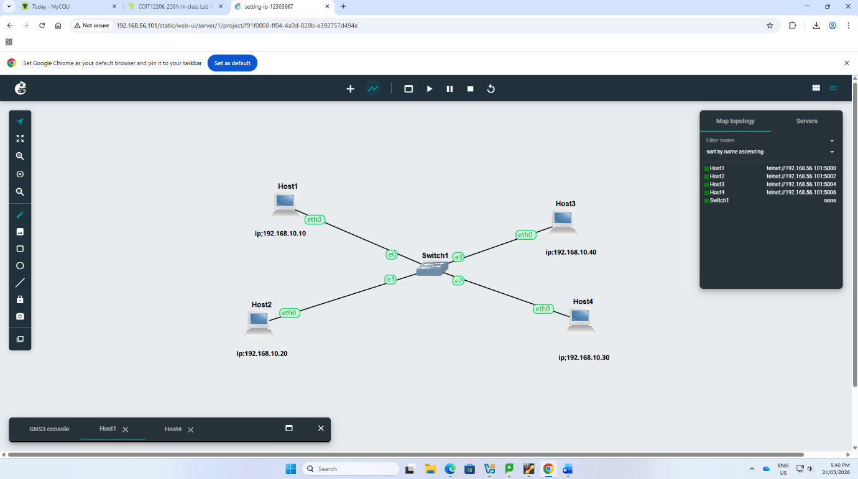

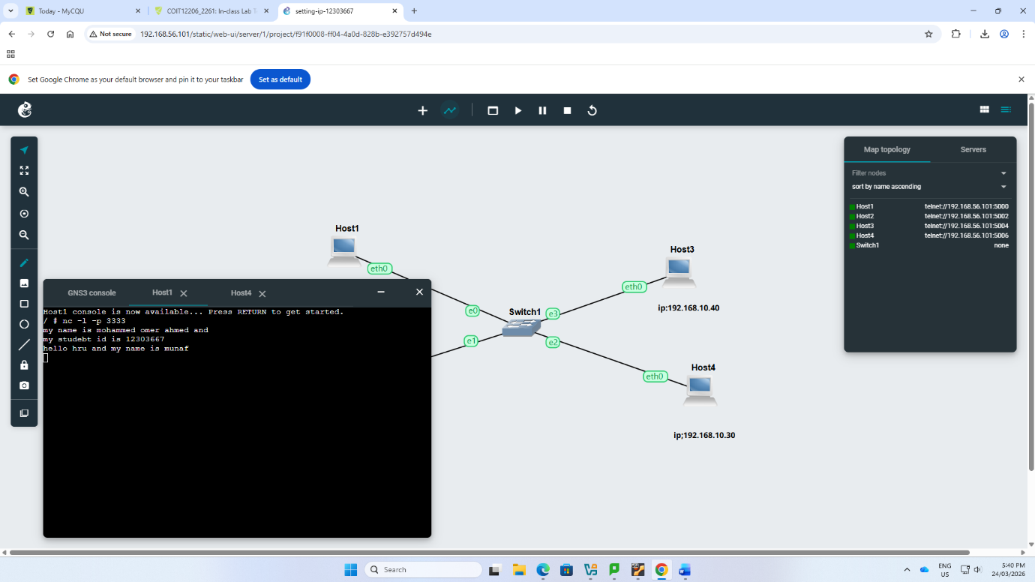
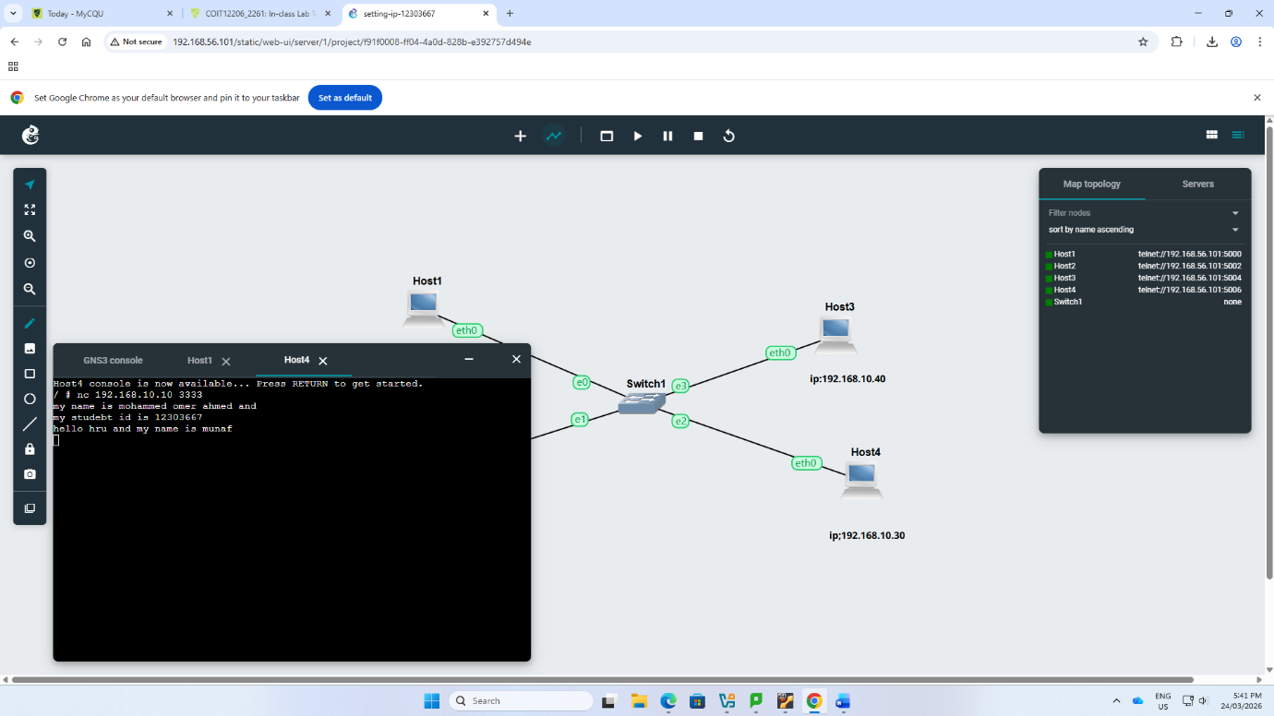
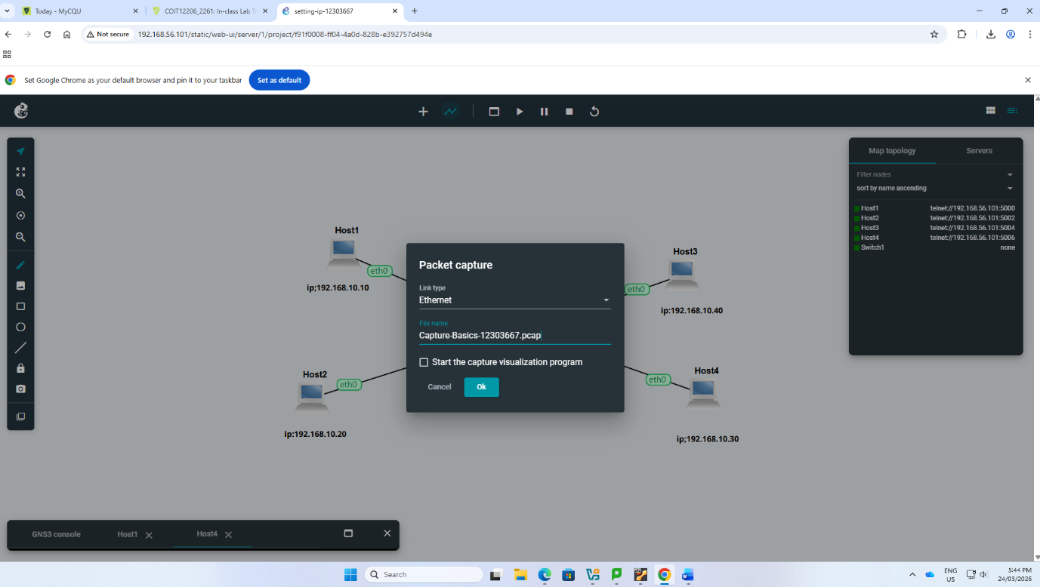
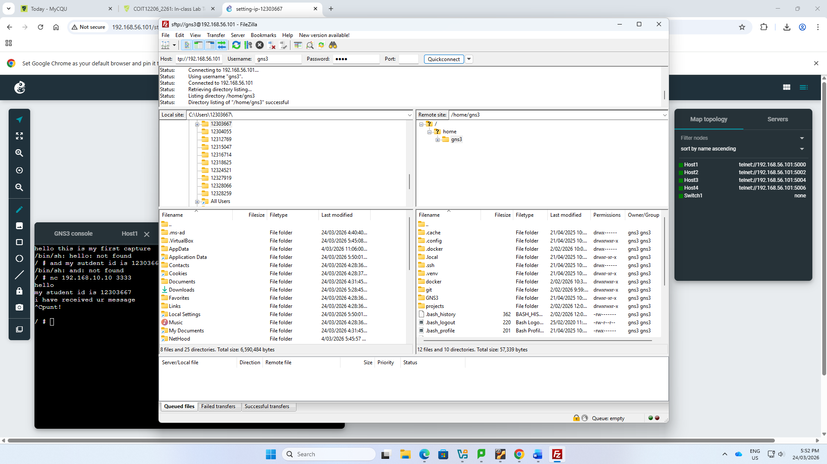
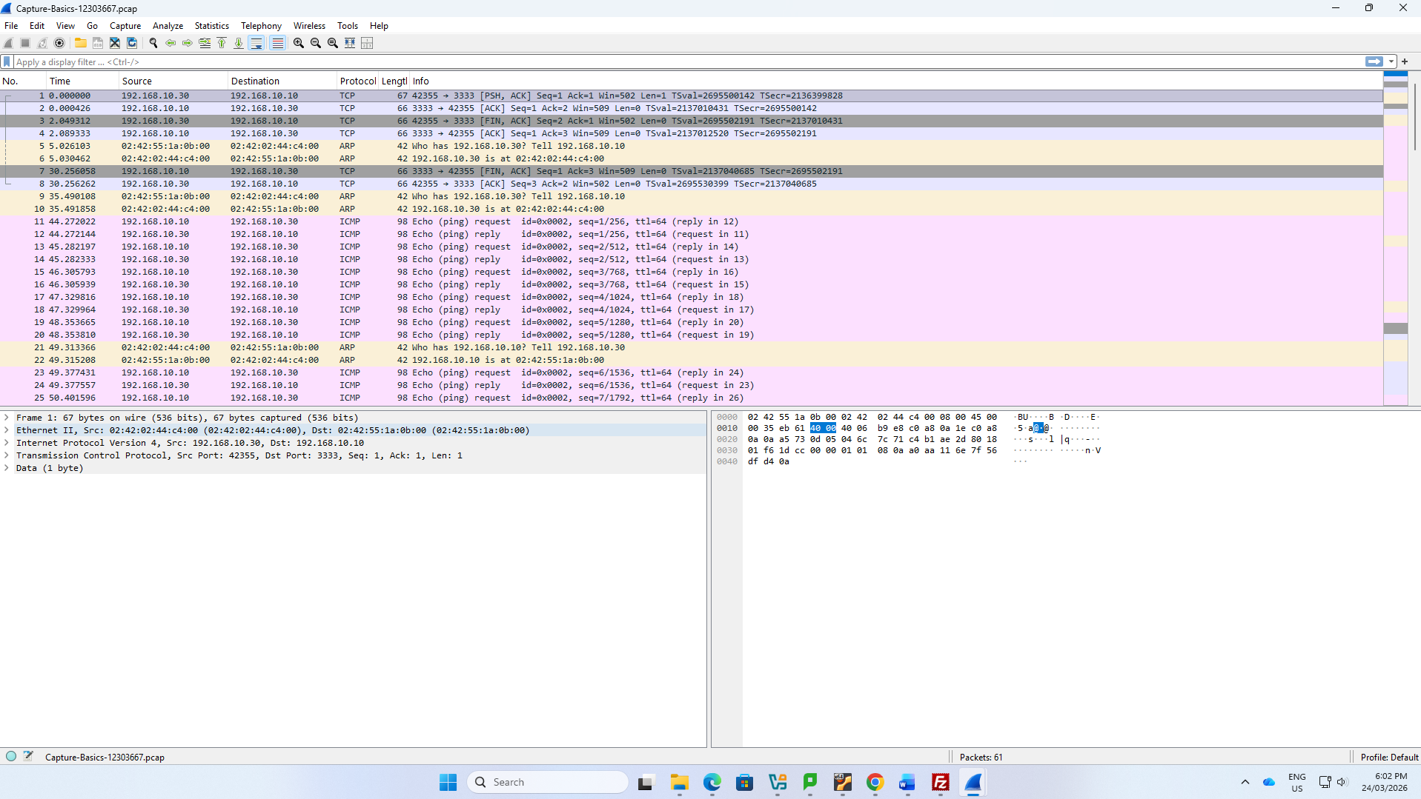
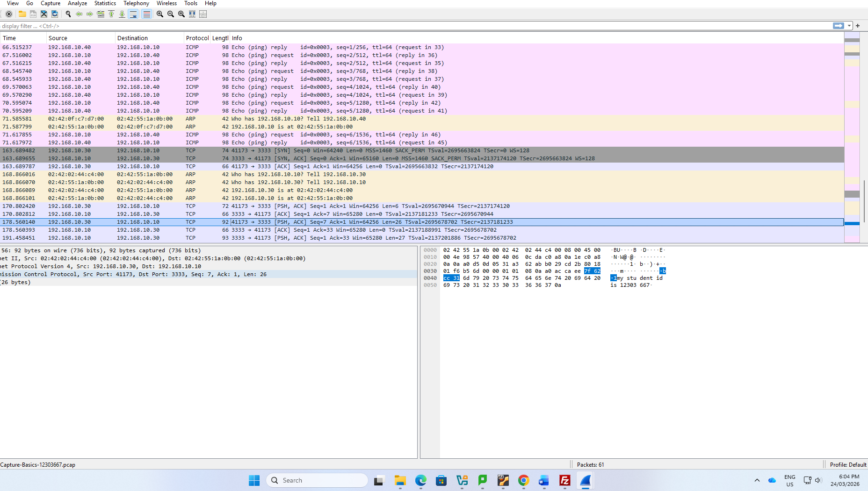
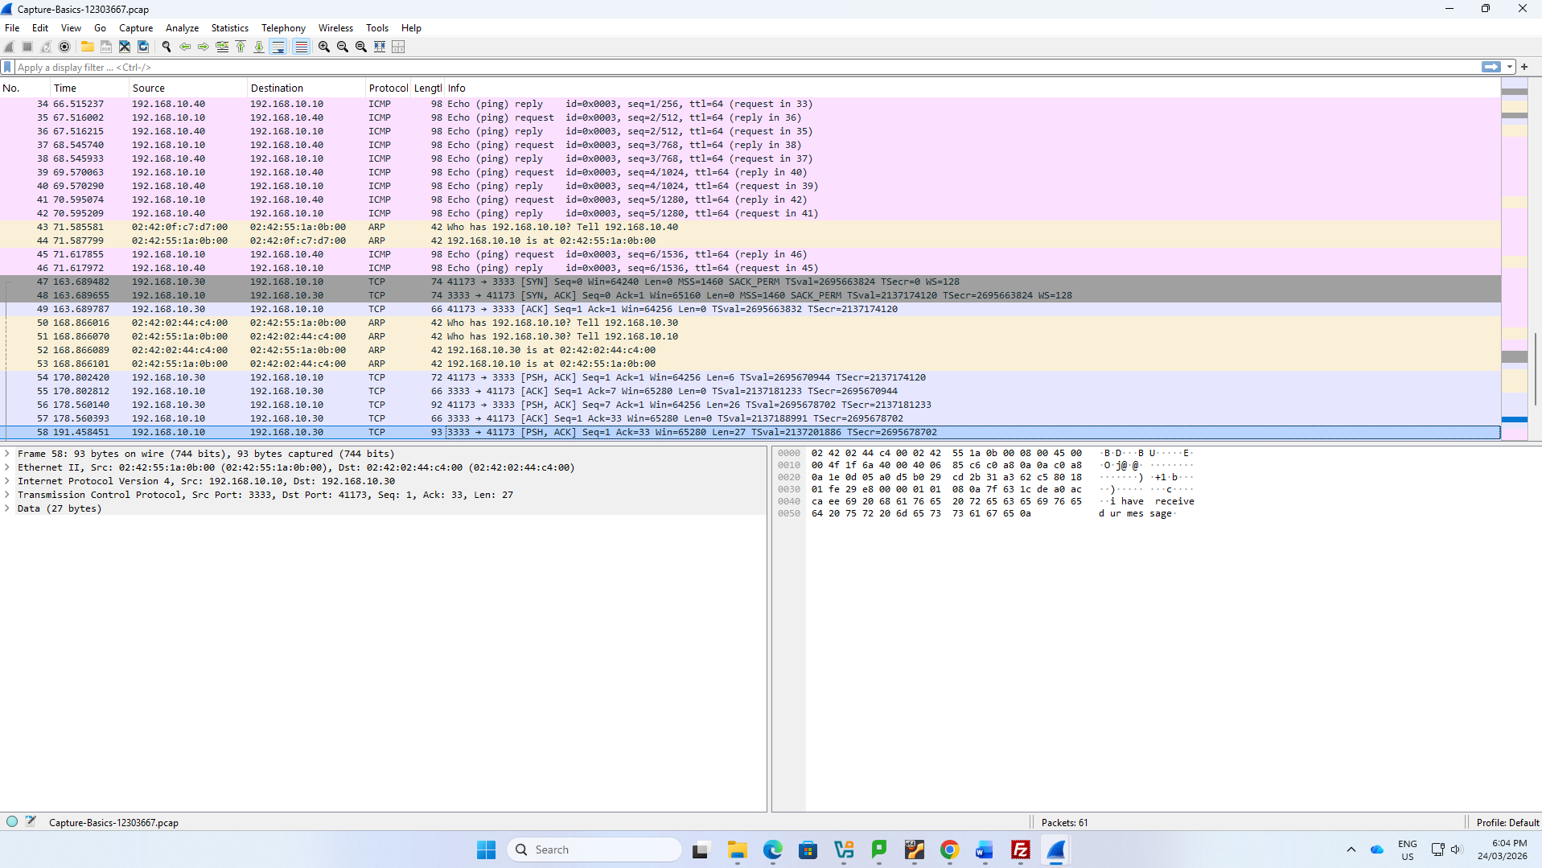

🔍 Reflection

Through this tutorial, I was able to learn how devices communicate across a network. Netcat demonstrated the principles of a simple client-server communication and the exchange of messages in real time. My other lesson was the distinction between ping (network layer) and Netcat (application layer).

It was also helpful to capture packets in GNS3 to observe the traffic flow in the network. The only minor problem was locating and transferring the capture file, which taught me a little more about the system. In general, the tutorial helped me to understand the basics of networking and troubleshooting.

